|  |  |
| --- | --- |
|  | http://3.bp.blogspot.com/-wFQHNun-UIo/T_D14NdbksI/AAAAAAAAHnk/DghvQ2NhSWQ/s1600/eyes.gif |

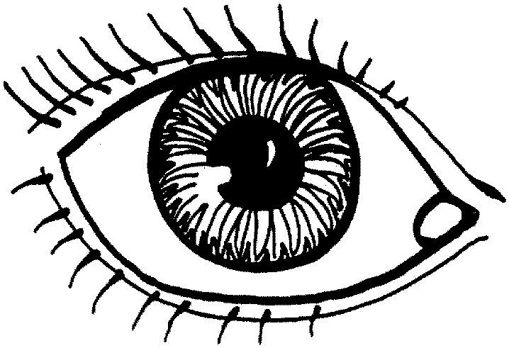NOURDIN

|  |  |
| --- | --- |
|  |  |
|  | http://3.bp.blogspot.com/-wFQHNun-UIo/T_D14NdbksI/AAAAAAAAHnk/DghvQ2NhSWQ/s1600/eyes.gif |

FATMA



MUSTAPH



NADIA



ABDOU KARIM



MOHAMED



FATOUMATA



FOFANA



ASSIYA



KAMA



SEIKOU



RAMATA



YOUSOUF



ABDESLAM



FANTA



RACHID



EBRIMA



     FANTA



 JANA



 SANE



NATTO



ABDESLAM



MOHAMED



SAMBA



DALLO



MALANG



HAMADY